CPS Week Reception in the Mildred Lane Kemper Art Museum at Washington University in St.Louis (Danforth Campus)

Monday, April 21, 2008, from 6:30 pm to 8:30pm

Sponsored by the School of Engineering at Washington University in St. Louis, and the Center for Hybrid and Embedded Software Systems at UC Berkeley

We are pleased to invite all registered attendees of the CPS Week workshops and conferences to a reception at the Mildred Lane Kemper Art Museum on the Danforth Campus of Washington University in St. Louis, 6:30-8:30pm on Monday April 21, 2008.
We are grateful for support from the sponsors of this special event: the School of Engineering at Washington University in St. Louis and the Center for Hybrid and Embedded Software Systems (CHESS) at UC Berkeley.
The reception will feature drinks and appetizers, and a student jazz band, as well as a chance to walk through the museum's collection and to interact with your colleagues. The museum’s shop will remain open during the reception, and for those interested it will offer all attendees the Washington University student/faculty discount of 10%.
Weather permitting, the reception will expand onto the patio facing Forest Park as well as the gallery spaces inside. Upon arrival at the corner of the museum that faces Brookings Drive and Forest Park (see picture below), please enter through the North Entrance to the museum from that patio (the sculptures on the patio are a good landmark for where to go).

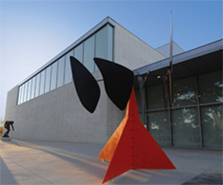
(image courtesy of Washington University in St. Louis)

Please see the other side of this page for options and directions for transportation to and from the museum, starting from the Renaissance Grand Hotel.

Travel by train: The easiest way to get to and from the museum is to walk from the Renaissance Grand Hotel to the Convention Center Station (go from B to A in the figure below and to the left) of the Metrolink light rail system, purchase (about $2) and validate a one-way ticket, and please make sure to take a Westbound train bound for Shrewsbury (not for the airport) to the Skinker Station (on the way back you can take any Eastbound train) and walk to the art museum (go from A to B in the figure below and to the right). If you would like to follow along with a group of people, a number of us will meet in the hotel lobby at 6pm, and will leave to walk to the train at 6:10pm.

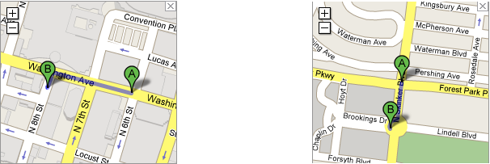

Travel by car/taxi (8 miles, 15 to 20 minutes, see route map below): Go south on 8th St. and turn right onto Market St. Turn left onto 10th St. and take the on-ramp onto highway US-40/I-64. After a little under 6 miles, take the Skinker/Clayton exit and turn right onto Skinker Blvd. Turn left onto Forsyth Blvd, right onto Hoyt Dr, and right onto Brookings Drive. If driving, please use a metered parking space along Brookings Drive.

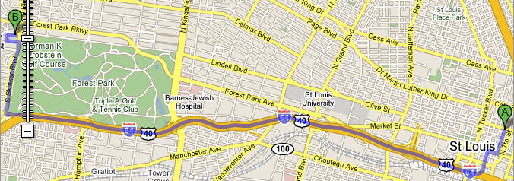
(image courtesy of Google Maps)

