Lab 6: Network Services: DNS, DHCP, FTP and HTTP
Name:
Date:

Objectives
Objective: Set up various network services
- Setup a DNS server
- Setup a DHCP server
- Setup an FTP server
- Setup a web server

Background Reading
Read sections about DNS and become familiar with the protocols DHCP, FTP and HTTP. The daemontools utility will be used to handle the DNS and DNS cache servers so become familiar with this utility.

Required Equipment
- Multiple operational networks
- daemontools utility
- Service packages

Excercises
Students will perform the following tasks and explain:
a)How they did them.
b)Why they were/were not successful.
c)What they observed.
Use the following diagram for the lab.
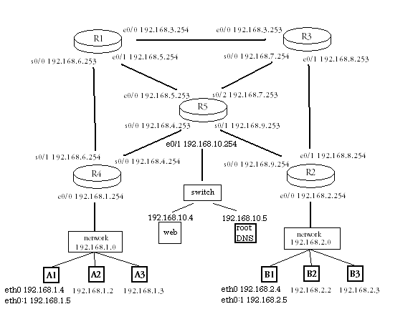

1____Setup a DNS server

- Install the daemontools utility and the djbdns package
Untar daemontools and djbdns
For daemontools cd into admin/daemontools and run install
root # install
For djbdns cd into the djbdns directory and run make followed by make setup check
root # make
root # make setup check
This should complete the install

- configure separate ip addresses for the dns server and the dns-cache server
Why is it necessary to do this?(The DNS and DNS-cache servers must be on different hosts)
Stop the network

/etc/init.d/network stop

Remove entries from the routing table and reconfigure interfaces

ifconfig lo 127.0.0.1 netmask 255.0.0.0
ifconfig eth0 192.168.1.4 netmask 255.255.255.0
ifconfig eth0:1 192.168.1.5 netmask 255.255.255.0

- Make sure new information is in the routing table

route add –net 127.0.0.0 netmask 255.0.0.0 dev lo
route add –host 192.168.1.4 netmask 255.255.255.0 dev eth0
route add –host 192.168.1.5 netmask 255.255.255.0 dev eth0:1
route add –net default gw 192.168.1.254

- Make a new directory for the servers

mkdir /var/djbdns

- Add users for the new services

adduser –s /bin/false tinydns
adduser –s /bin/false dnscache
adduser –s /bin/false dnslog

- Configure the dns server

tinydns-conf tinydns dnslog /var/djbdns/tinydns 192.168.1.5

- Add entries to the dns and make the datafile
Change to directory /var/djbdns/tinydns/root

add-ns alpha.com 192.168.1.5
add-ns 1.168.192.in-addr.arpa 192.168.1.5
add-host a.alpha.com 192.168.1.1
add-host b.alpha.com 192.168.1.2
add-host c.alpha.com 192.168.1.3
add-host dns-cache.alpha.com 192.168.1.4
add-host dns.alpha.com 192.168.1.5
make

- Create a symbolic link for the daemontools utility

ln –s /var/djbdns/tinydns /service

- Test name resolution using the host command

host b.alpha.com

- Configure the cache server

dnscache-conf dnscache dnslog /var/djbdns/dnscachex 192.168.1.4

- Set the root server and add the local network
Change directories to /var/djbdns/dnscachex/root/servers
Edit the @ file to include the address of the root server 192.168.10.5
touch 192.168.1 to add the local network

- Add the cache files
Create the file alpha.com and add the cache server’s address 192.168.1.4
Copy the file for reverse lookup

cp alpha.com 1.162.198.in-addr.arpa

- Create a symbolic link for daemontools

ln –s /var/djbdns/dnscachex /service

- Configure root DNS server

Perform the steps above on the root server host with the following exceptions:
Skip ip aliasing
Do not setup the cache server
Add the following to the DNS lookup file
add-ns . 192.168.10.5
add-childns alpha.com 192.168.1.5
add-childns beta.com 192.168.2.5
add-childns 1.168.192.in-addr.arpa 192.168.1.5
add-childns 2.168.192.in-addr.arpa 192.168.2.5

- Verify DNS is working by using the host command to resolve host names to ip addresses

2____Setup a DHCP server

- Configure the DHCP script to reflect the network’s information and the range of addresses

- Copy the configuration file to /etc/init.d

- Start the DHCP server

/etc/init.d/dhcpd start

- Remove the ip address from another host’s ethernet interface(not a host running a service)

- Use the dhclient command to get the host to contact the DHCP server for a new ip address

3____Setup an FTP server

- Create a non-priveledged user for anonymous use

- Configure the /etc/xinetd/vsftp.conf script
Change the file to enable anonymous, set the anonymous user name and comment out the write enabled line

- Change the vsftp.conf script to enable the server

Disable = no

- Start the FTP server

/etc/init.d/vsftpd start

- Verify the FTP server is running using netstat –atp

- Test the FTP server by logging in

4____Setup a web server

- Configure the httpd script

- Make sure the listening port is set to the appropriate port

- Verify the user and group settings are not root

- Assign a name for the server

- Verify the “document root” is set to the root directory of where the HTML files are located

- Start the Web server

/etc/init.d/httpd start

- Verify the server is running using netstat –atp

- Test the server by connecting to the appropriate port

