Lab 7: Content Distribution
Name:
Date:

Objectives
Objective: Learn how content distribution works
- Review lab6 for DNS and HTTP servers
- Learn to use the command wget to support content distribution

Background Reading
Read sections about content distribution. Review lab6 for how to set up a DNS server and a HTTP server. Read the man pages on wget.

Required Equipment
- Operational networks
- Three DNS servers
- Three web servers

Excercises
Students will perform the following tasks and explain:
a)How they did them.
b)Why they were/were not successful.
c)What they observed.

1____Content Distribution

In order to simulate a CDN we performed the following procedures.
- setup an ip alias to identify requests from different networks
ifconfig eth0:1 192.168.10.4 netmask 255.255.255.0
- configured an additional DNS server for the other network
tinydns-conf tinydns dnslog /var/djbdns/tinydns2
ln -s /var/djbdns/tinydns2 /service
cp /var/djbdns/tinydns/root/data /var/djbdns/tinydns2/root/data
cd /var/djbdns/tinydns2/root
add-host cdn.omega.com 192.168.1.4
make
cd /var/djbdns/tinydns/root
add-host cdn.omega.com 192.168.2.4
make
- configured route for prerouting
route add –host 192.168.10.4 netmask 255.255.255.0 eth0:1
- setup prerouting to discriminate requests
iptables -A PREROUTING -s 192.168.1.0/24 –d 192.168.10.5 –p UDP
--dport 53 -j DNAT -t nat --to-destination 192.168.10.4
use the following diagram for this lab

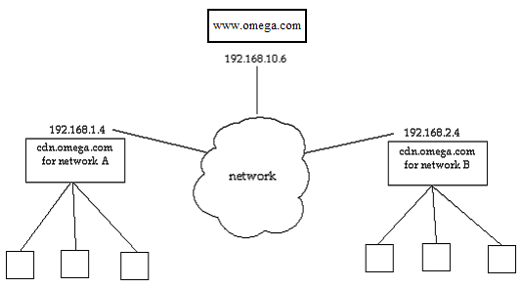

- start the web server on each of the two networks(see lab 6)

- create a simple web page on the Content Distribution Network host 192.168.10.6 Name the file index.html

- add a link in the index page to an image file from the content distribution site cdn.omega.com

- on each sub-network’s web server perform wget on the CDN’s web page

root# wget -k --mirror -- span-hosts www.omega.com

- verify the retrieval of the images from the respective network

--12:02:03-- http://www.omega.com/
=> `www.omega.com/index.html'
Resolving www.omega.com... done.
Connecting to www.omega.com[192.168.10.6]:80... connected.
HTTP request sent, awaiting response... 200 OK
Length: 147 [text/html]
The sizes do not match (local 143) -- retrieving.
--12:02:03-- http://www.omega.com/
=> `www.omega.com/index.html'
Connecting to www.omega.com[192.168.10.6]:80... connected.
HTTP request sent, awaiting response... 200 OK
Length: 147 [text/html]

100%[========================================>] 147 143.55K/s ETA 00:00

12:02:03 (143.55 KB/s) - `www.omega.com/index.html' saved [147/147]

Loading robots.txt; please ignore errors.
--12:02:03-- http://cdn.omega.com/robots.txt
=> `cdn.omega.com/robots.txt'
Resolving cdn.omega.com... done.
Connecting to cdn.omega.com[192.168.1.4]:80... connected.
HTTP request sent, awaiting response... 404 Not Found
12:02:03 ERROR 404: Not Found.

--12:02:03-- http://cdn.omega.com/some.png
=> `cdn.omega.com/some.png'
Connecting to cdn.omega.com[192.168.1.4]:80... connected.
HTTP request sent, awaiting response... 200 OK
Length: 3,613 [image/png]
Server file no newer than local file `cdn.omega.com/some.png' -- not retrieving.

FINISHED --12:02:03--
Downloaded: 147 bytes in 1 files
Converting www.omega.com/index.html... 1-0
Converted 1 files in 0.00 seconds.

- run traceroute to the following locations to illustrate the usefulness
What are the time differences if transmissions?

local network’s web server
CDN network
Other network’s web server

