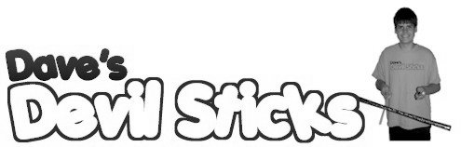

**Who Am I?**

Welcome to **Dave's Devil Sticks**. If you are looking for juggling balls, hacky sacks, pins, unicycles, or magic hats, you've come to the wrong place; but if you're looking for high-quality, hand-crafted devil and flower sticks, this is the site for you. I've been designing and building sticks for the past 20 years, and I know that my sticks are the best of their kind. Don't take my word for it; read the following testimonial:

I'm more than happy to recommend Dave Vinet's products. I came upon his work 10 years ago and was immediately impressed by his craftsmanship. I've been using his sticks in my shows ever since. They're durable, well-balanced, and attractive props and are the perfect complement to my performances. Thanks Dave!

— Thomas Gage, lead performer at *Circus England*

Every set is checked and tested before being shipped out to assure perfect quality. I take pride in every one of my sticks and I want my customers to feel that same pride.

**My Products**

* **Basic Stick**  
  The easiest stick to learn with, but "grippy" enough for the most demanding tricks. Comes in red, green, and blue.
* **Flower Stick**  
  A graceful stick with colored tassels. Flower Sticks float more slowly, giving you the ideal chance to practice new moves.
* **Master Stick**  
  My most popular stick is shorter and heavier for fast play and more advanced tricks. Each Master set is available in custom colors.
* **Glow Stick**  
  The Glow Stick shines brightly at night (without the danger of a fire stick). It combines the fun and versatility of the Master Stick, adding the fun tricks unique to a glow-in-the-dark stick.

*Dave's Devil Sticks • 541 West Highland Dr. • Auburn, ME 04210 • (207) 555 - 9001 •*